**1.Create a simple cloud software application for Flight Reservation System using any Cloud Service Provider to demonstrate SaaS**

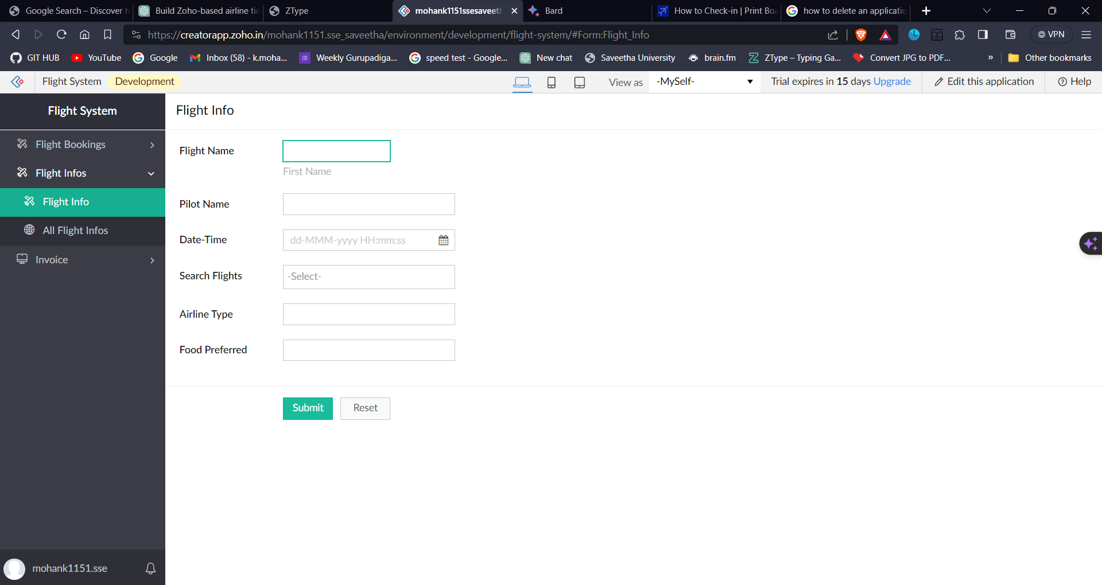

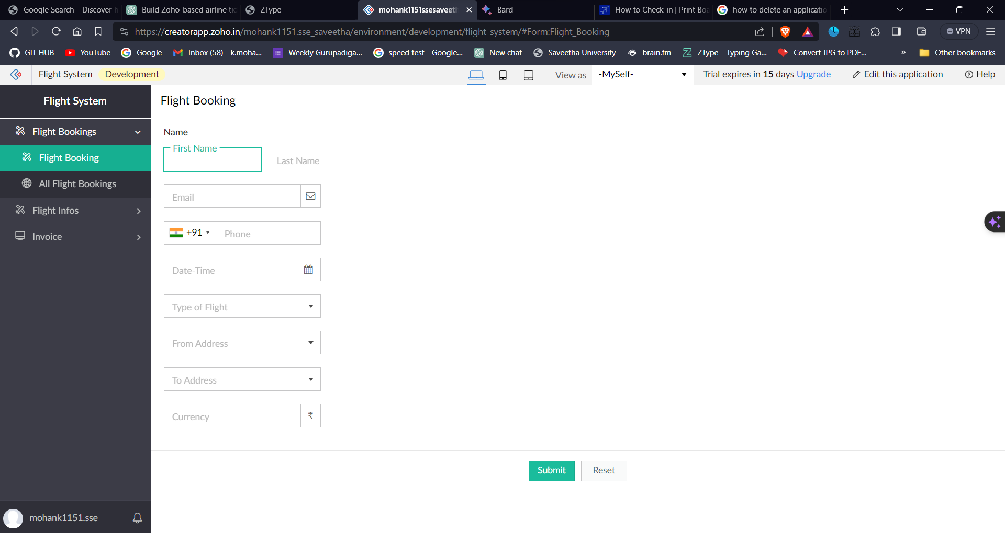**aS**

